**IPSHealth Assignment Instruction Document.**

1. **Launch Project in Visual Studio**
2. **Press run button and wait for program to launch in web browser.**

**Picture below for reference.**

1. **User who can do all CRUD methods is already signed in.**
2. **Due to current work constraints and time available. I had to make user already signed in.**
3. **Press index to see data already added and to be able to create, edit and delete data.**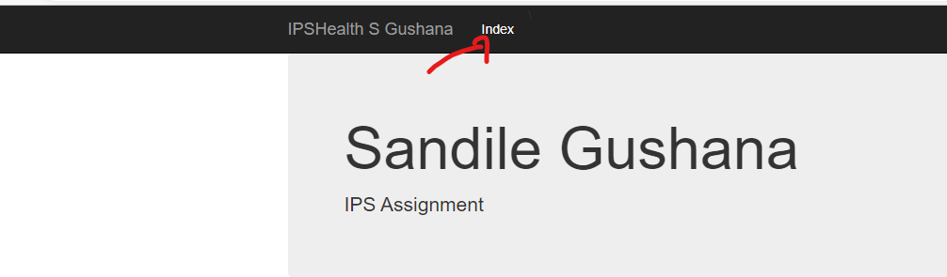
4. **The design is simple to follow for all people who are tech and not tech savvy. Everyone an index contains info of something in this case user data or client data.**

**Thank you for this opportunity to write code and be tested.**